**Signal Detection**

Course name- PSY310: Lab in Psychology

Date- 28/09/2023

Name- Rishitaa Joshi

Enrollment no.- AU2120095

**GITHUB:**

**Introduction**

A visual search task can be defined as a cognitive activity in which an individual is presented with visual stimuli, such as images or objects and is required to identify or locate a specific target item within the visual field. Visual search tasks are usually used in psychology and cognitive science research to study visual perception, attention and information processing. Some of the key aspects of visual search tasks include stimulus presentation, target identification, response task, experimental manipulation and measures.

In a visual search task, speed and accuracy can be considered as important criteria. Visual search tasks are valuable tools in the study of attention because they allow researchers to investigate how individuals allocate their attention to different objects in a visual scene. They help in examining how attention is selectively directed toward specific objects or features within a complex visual field.

**METHOD**

***Participant***

The participants were students of the Lab in Psychology course at Ahmedabad University. All the participants had normal vision.

***Materials and procedure***

The experiment was designed by using a python based software, Psychopy. The experimenter was provided a video explaining how to design the visual grating task by the professor of the course. The materials used by the experimenter was their personal laptop.

At the beginning of the experiment a fixation stimulus was added followed by the shapes, alphabets, codes and mouse responses. The fixation stimulus was a “+” and appeared on the center of the screen for every participants in each trial. As this was a visual search task, the main task of the participants was to find the letter “T” among several other “L”. In order to analyse the reaction time when the number of distraction stimulus were more, the time for each response was recorded.

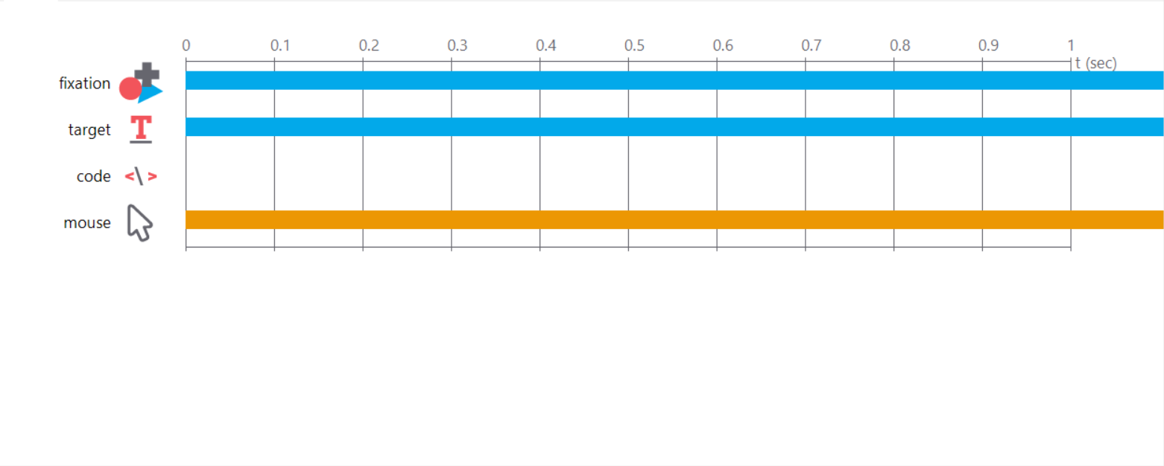

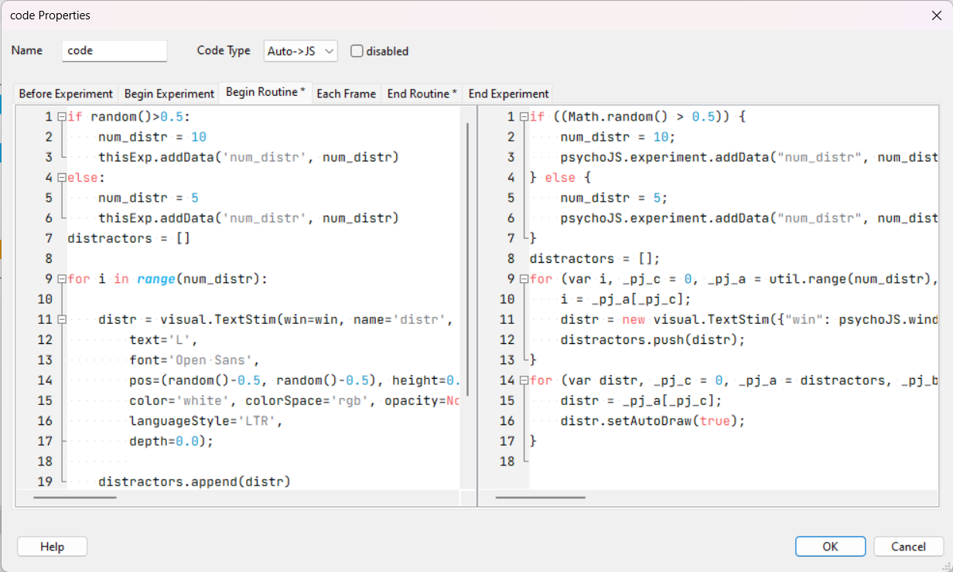

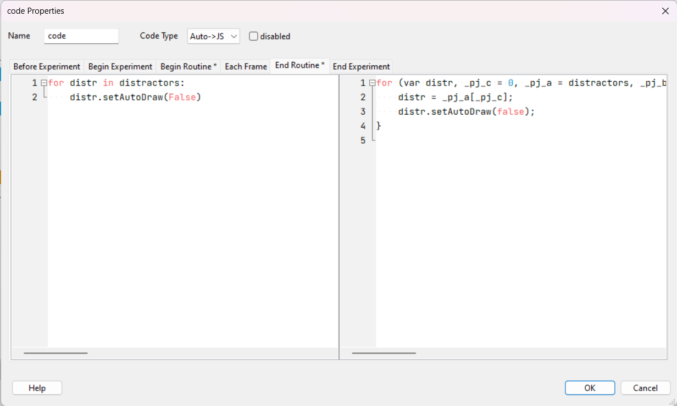

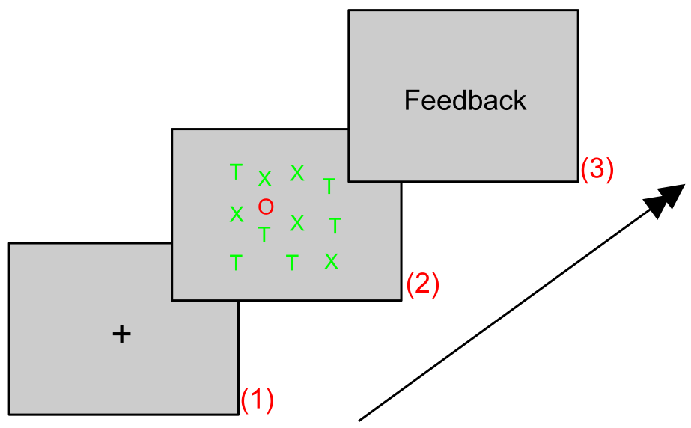

***Testing Conditions***

The participants performed 200 trials in one session. It was made sure that the participants were not able to get distracted by the environment. Participants performed the task without any breaks in between.

***Data Collection***

The data was automatically collected through PsychoPy in an excel file. The data was then refined to analyse the required the values efficiently. It was then merged and categorized to calculate the reaction times and set sizes. The mean reaction time for all 4 participants for set size 5 was 1.84612 and for set size 10 was 2.222082

|  |  |  |
| --- | --- | --- |
| Mean | Set Size 5 | Set Size 10 |
| Participant 1 | 1.786721 | 2.479146 |
| Participant 2 | 2.077582 | 2.287732 |
| Participant 3 | 1.749519 | 2.126056 |
| Participant 4 | 1.770657 | 1.995394 |

***Results***

After conducting an analysis of the data collected, two set sizes were made : set size 5 and set size 10.

**DISCUSSION**

The slope was calculated by using the following formula SLOPE = (Y2 - Y1) / (X2 - X1). Through the analysis we found that more reaction time indicates that the participant is less attentive and takes longer to find the target stimulus. On the other hand the shorter the reaction time, the more attentive the participant is in finding the target stimulus. For calculating the slope, the mean reaction times for set size 5 and set size 10 of all four participants was calculated. Then the mean reaction times of set size 10 was subtracted by set size 5 which was then divided by 5. It was also observed that the increase in number of distractors resulted in an increase in reaction time which means that when there were more distractors it took longer for participants to recognise the target stimulus. Whereas on the other hand when there were a less number of distractors the participants recognised the target stimulus quickly

**REFERENCES**

Hansen, M. (2016). PyVDT: A PsychoPy-Based Visual Sequence Detection Task. Journal of Open Research Software, 4(1), e22.DOI: <https://doi.org/10.5334/jors.117>